**NITTE MEENAKSHI INSTITUTE OF TECHNOLOGY**

(AN AUTONOMOUS INSTITUTION, AFFILIATED TO VISVESVARAYA TECHNOLOGICAL UNIVERSITY, BELGAUM, APPROVED BY AICTE & GOVT.OF KARNATAKA



***COVID MANAGEMENT***

*Submitted in partial fulfilment of the requirement for the INTRODUCTION TO WEB APPLICATION DEVELOPMENT subject in IV sem*

*Bachelor of Engineering*

*in*

*Computer Science and Engineering*

*Submitted by:*

|  |  |
| --- | --- |
| ***KINSHUK CHATURVEDI*** | ***1NT18CS076*** |
| ***PREET CHAHAL*** | ***1NT18CS119*** |
| ***PRANAV SHRIVASTAVA*** | ***1NT18CS115*** |
| ***SAILESH PANDEY*** | ***1NT18CS201*** |

Under the Guidance of

GUIDE NAME

DESIGNATION, Dept. of CS&E, NMIT



Department of Computer Science and Engineering

2019-20

**NITTE MEENAKSHI INSTITUTE OF TECHNOLOGY**

(AN AUTONOMOUS INSTITUTION, AFFILIATED TO VISVESVARAYA TECHNOLOGICAL UNIVERSITY, BELGAUM

, APPROVED BY AICTE & GOVT.OF KARNATAKA)

Department of Computer Science and Engineering

**(Accredited by NBA Tier-1)**



**CERTIFICATE**

This is to certify that the report on **COVID MANAGEMENT** is an authentic work carried out by ***KINSHUK CHATURVEDI (1NT18CS076), PREET CHAHAL (1NT18CS119)*** and ***PRANAV SHRIVASTAVA (1NT18CS115)*** and ***SAILESH PANDEY(1NT18CS201)*** Bonafede students of **Nitte Meenakshi Institute of Technology**, Bangalore in the partial fulfilment for the Course “INTRODUCTION TO WEB APPLICATION DEVELOPMENT” in IV Sem of the degree of ***Bachelor of Engineering*** in **COMPUTER SCIENCE AND** **ENGINEERING** of Visvesvaraya Technological University, Belagavi during the academic year ***2019-20.*** It is certified that all corrections and suggestions indicated during the internal assessment has been incorporated in the report.

**ACKNOWLEDGEMENT**

The satisfaction and euphoria that accompany the successful completion of any task would be incomplete without the mention of the people who made it possible, whose constant guidance and encouragement crowned our effort with success. I express my sincere gratitude to our **Principal** **Dr. H. C. Nagaraj**, Nitte Meenakshi Institute of Technology for providing facilities.

We wish to thank our **HOD, Dr. Thippeswamy M. N.** for the excellent environment created to further educational growth in our college. We also thank him for the invaluable guidance provided which has helped in the creation of a better project.

I hereby like to thank our **Ms. Uma R , Associate Professor**, Department of Computer Science & Engineering on **her** periodic inspection, time to time evaluation of the project and help to bring the project to the present form.

We take this opportunity to thank our Departmental Project coordinators. We also thank all our friends, teaching and non-teaching staff at NMIT, Bangalore, for all the direct and indirect help provided in the completion of the project.

|  |  |  |
| --- | --- | --- |
| **NAME** | **USN** | **Signature** |
| ***KINSHUK CHATURVEDI*** | ***1NT18CS076*** |  |
| ***PREET CHAHAL*** | ***1NT18CS119*** |  |
| ***PRANAV SHRIVASTAVA*** | ***1NT18CS115*** |  |
| ***SAILESH PANDEY*** | ***1NT18CS201*** |  |

Date:

**ABSTRACT**

When you run a healthcare facility, proper disposal of medical waste plays an important role in ensuring the safety and overall health of staff, patients and visitors. With the amount of waste produced each day, healthcare offices must be constantly prepared, or else something could go wrong during any phase of the disposal process.

As we all know, currently the whole world is fighting against COVID19. This virus has already infected 3,950,444+ people globally and 271,796+ people have lost their lives due to this deadly virus.

Government has taken certain steps to slower down the spreading rate of the virus. Covid19 has caused a great damage to the global economy.

To protect ourselves from this harmful situation caused due to COVID19 i.e. CORONAVIRUS, we are advised to stay at home, wash our hands frequently with alcohol-based hand-rub or soap and practice social distancing . If you’re going outdoors, usage of masks, gloves .. etc. is mandatory. But IS THIS ENOUGH?

**TABLE OF CONTENTS**

|  |  |  |
| --- | --- | --- |
| Index | **CHAPTERS** | Page No |
| 1 | INTRODUCTION | 8 |
| 2 | LITERATURE SURVEY | 11 |
| 3 | SYSTEM REQUIREMENTS SPECIFICATIONS | 14 |
| 4 | DESIGN | 16 |
| 5 | RESULT AND SNAPSHOTS | 19 |
| 6 | CONCLUSIONS | 23 |
| 7 | REFERENCES | 25 |

* **DECLARATION**
* **ACKNOWLEDGEMENT**
* **ABSTRACT**
* **TABLE OF CONTENTS**
* **LIST OF FIGURES**
* **LIST OF TABLES**
* **LIST OF ACRONYMS**

**CHAPTER 1: INTRODUCTION**

* 1. Background
  2. Brief history of Technology/concept
  3. Applications
  4. Research motivation and Problem statement
     1. Research Motivation
     2. Statement of the Problem
  5. Research objectives and contributions
     1. Primary objectives
     2. Main contributions
  6. Organization of the report
  7. Summary

**CHAPTER 2: LITERATURE SURVEY**

* 1. Introduction
  2. Related work
  3. Study of Tools/Technology
  4. Summary

**CHAPTER 3: SYSTEM REQUIREMENTS SPECIFICATIONS**

3.1 General Description

3.1.1 Product Perspective

3.2 System Requirements

3.2.1 Hardware Requirements

3.2.2 Software Requirements

3.2.2.1 Functional Requirments & Non-functional Requirements

3.2.2.2 User Requirements

< This template illustrates organizing the functional requirements for the product by system features, the major services provided by the product. You may prefer to organize this section by use case, mode of operation, user class, object class, functional hierarchy, or combinations of these, whatever makes the most logical sense for your product.>

REQ-1:

REQ-2:

:

REQ-N:

3.3 Summary

**CHAPTER 4: DESIGN**

4.1 Architectural Design

4.2 Dataflow Diagram

4.3 Class Hierarchy Diagram

4.4 Usecase Diagrams

4.5 Sequence Diagrams

4.5 Activity Diagram

**CHAPTER 5: CONCLUSIONS**

**CHAPTER 6: REFERENCES**

**INTRODUCTION**

Face masks used by the general public could be a source of infection if not discarded properly. So it is our responsibility to dispose the used masks or gloves safely. It is wrong to throw them on roads, streets or any other public places, this may only lead to spreading of the virus as it has microorganisms sitting on it. Discard the used mask immediately in a separate closed bin at home and clean hands with alcohol-based soap. But keeping it at home could be dangerous too. This needs to be handled very carefully.

We have created a platform where you can schedule a pick-up of your medical waste at your doorsteps on desired date which is free of cost and we will be taking care of your medical waste i.e. where to dispose it and what to further do with it. We will also be providing you a batch of COVID HERO based on your response and activity towards us.

All you need to do is enter your details including your name, address , contact number , type of waste , quantity …etc. You can choose a desired date for your pickup and enter a 4-digit pin which you need to confirm at the time of pick-up. Your medical waste will be picked up by our member on desired date and address.

**APPLICATIONS -**

Convenience and safety is a major advantage of COVID management. It allows you to schedule a pickup for your medical waste making it convenient and safer for you and everyone else around you.

It is fast and efficient. The pickup can be scheduled according to your choice of time and place without any delay in the process.

Consumers can also monitor the COVID situation in India, it’ll display the total number of positive cases per state. They can also get the helpline number of their state and can take up self-assessment to check whether they’re showing any symptoms of covid19.

*Key Takeaways*

* Waste Management Tips
* Get home sanitised
* Waste Pick-up
* COVID India Helpline’s number
* COVID India updates
* Self-assessment

**LITERATURE**

**SURVEY**

**Present System:**

In the present system people keep the medical waste at their home until the normal garbage pickers come and collect it. This could be very dangerous for the garbage pickers , also incorrect method of the disposal of the medical waste could be harmful. Some people also throw the waste on the roads or public places due to lack of awareness and fear. Even a little bit of carelessness could lead to big blunders.

**Proposed System:**

***Covid Management*** is an initiative to spread awareness and to help control the spreading of the virus. Our skilled members come to your doorsteps to collect the medical waste which we very carefully dispose using all the precautions.

You can schedule the pick-up at any time or place of your choice.

We also provide sanitization facilities. We work for absolutely no cost and in return expect your support. We provide Covid Hero batches to those who actively help us create this environment covid free.

In addition to that, we also provide latest update on covid19 cases and helpline numbers of every state in India.

**CONCEPTS: -**

**HTML**

Hypertext Markup Language (HTML) is the standard markup language for documents designed to be displayed in a web browser. Web browsers receive HTML documents from a web server or from local storage and render the documents into multimedia web pages. HTML describes the structure of a web page semantically and originally included cues for the appearance of the document

**CSS**

Cascading Style Sheets (CSS) is a style sheet language used for describing the presentation of a document written in a markup language like HTML. CSS is designed to enable the separation of presentation and content, including layout, colors, and fonts.This separation can improve content accessibility, provide more flexibility and control in the specification of presentation characteristics.

**PHP**

PHP is a popular general-purpose scripting language that is especially suited to web development. On a web server, the result of the interpreted and executed PHP code – which may be any type of data, such as generated HTML or binary image data would form the whole or part of a HTTP response.

**MYSQL**

MySQL server is a open-source relational database management system which is a major support for web based applications.

**JAVASCRIPT**

JavaScript is a lightweight, cross-platform and interpreted scripting language.

It is well-known for the development of web pages, many non-browser environments also use it.

**JQUERY**

JQuery is an open source JavaScript library that simplifies the interactions between an HTML/CSS document, or more precisely the Document Object Model (DOM), and JavaScript.

**AJAX**

Ajax is an acronym for Asynchronous JavaScript and XML.

It is used to communicate with the server without refreshing the web page and thus increasing the user experience and better performance.

**SYSTEM REQUIREMENTS SPECIFICATIONS**

**SOFTWARE REQUIREMENTS:**

**SOFTWARE USED:**

* **XAMPP server**
* **VS code**

**TECHNOLOGY USED:**

* HTML 5
* CSS
* PHP
* MYSQL
* JAVASCRIPT
* JQUERY
* AJAX

**OPERATING SYSTEM**: Windows 10

**HARDWARE REQUIREMENTS:**

**PROCESSOR**: LAPTOP i5 8TH

**MEMORY**:8 GB RAM.

**HARD DISK SPACE**: 2 TB

**MONITOR**:15.6 INCH LAPTOP

**DISPLAY:** IPS DISPLAY (1366 * 768)

RESULT

AND

SNAPSHOTS

**SELF ASSESSMENT PAGE**:

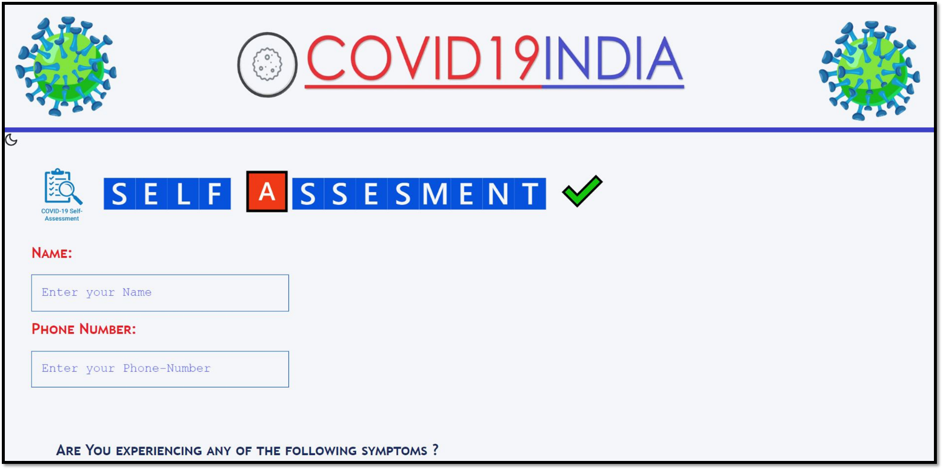

**REGISTRATION PAGE:**

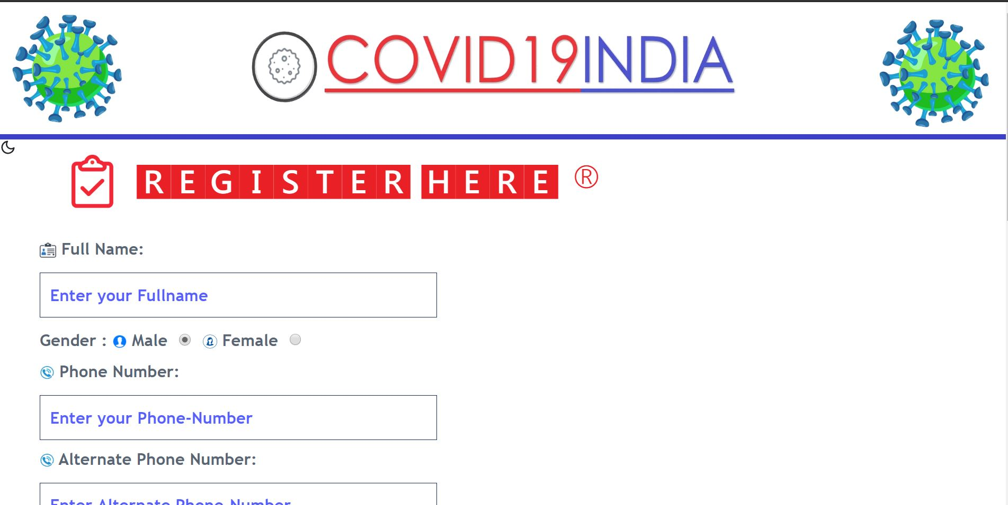

**HOMEPAGE:**

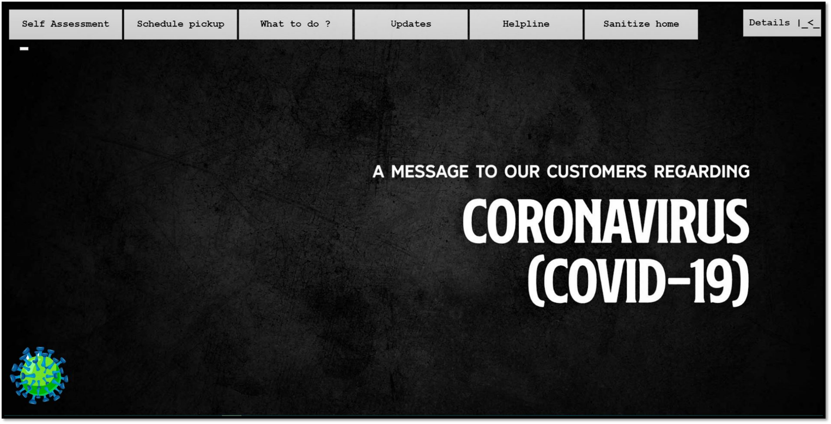

**HOME SANITIZING SERVICE PAGE:**

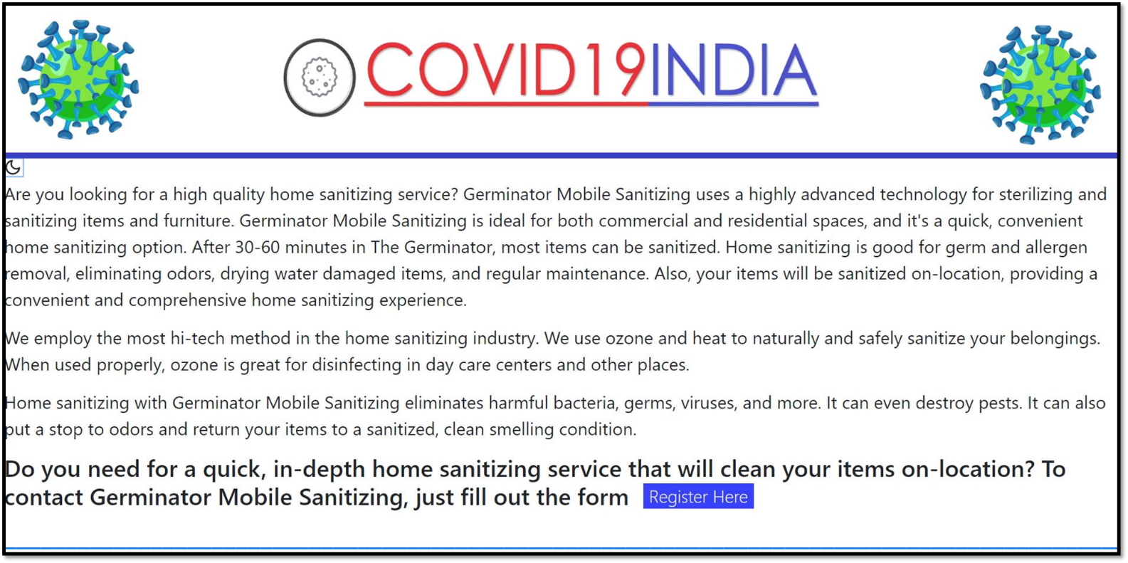

**SELF CARE AND PREVENTION GUIDE:**

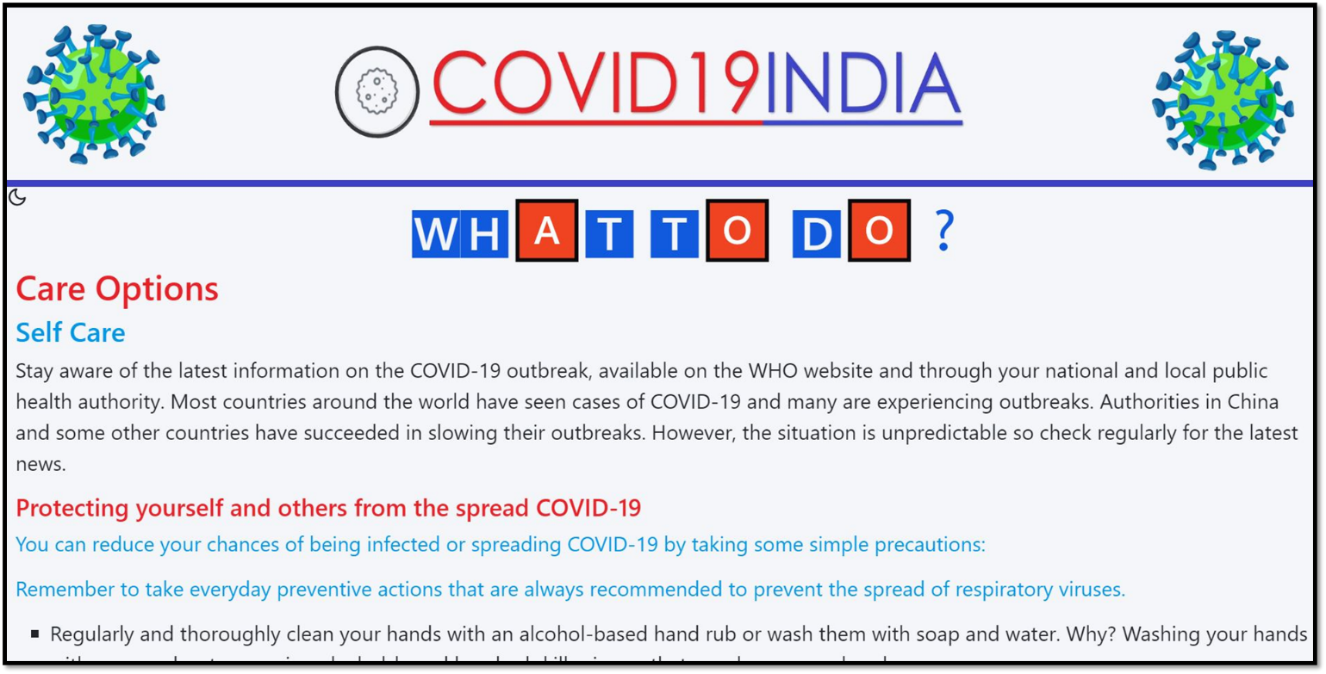

**DARK MODE:**

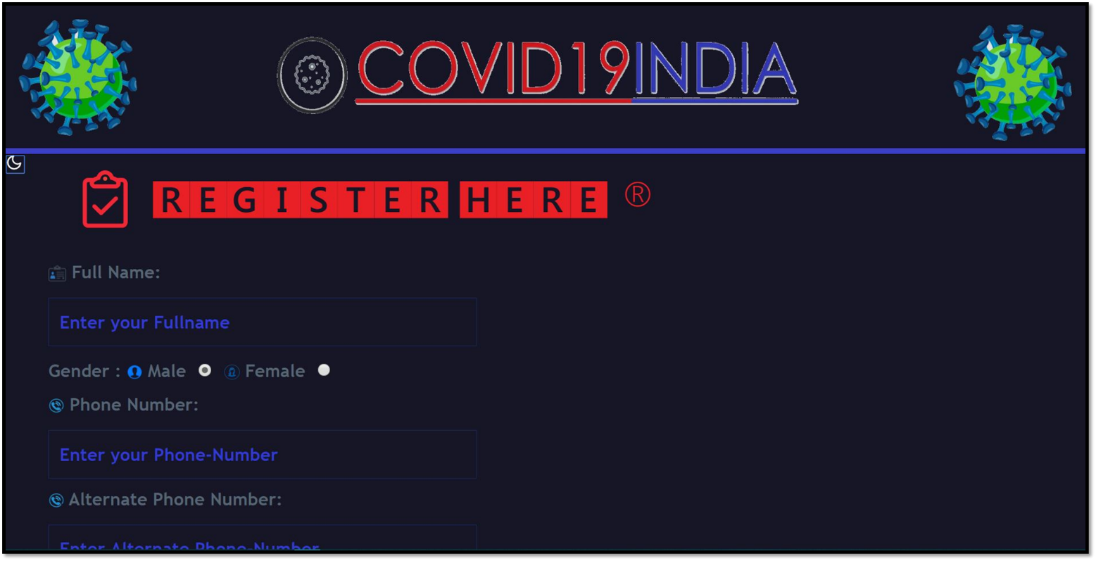

**ADMIN PAGE:**

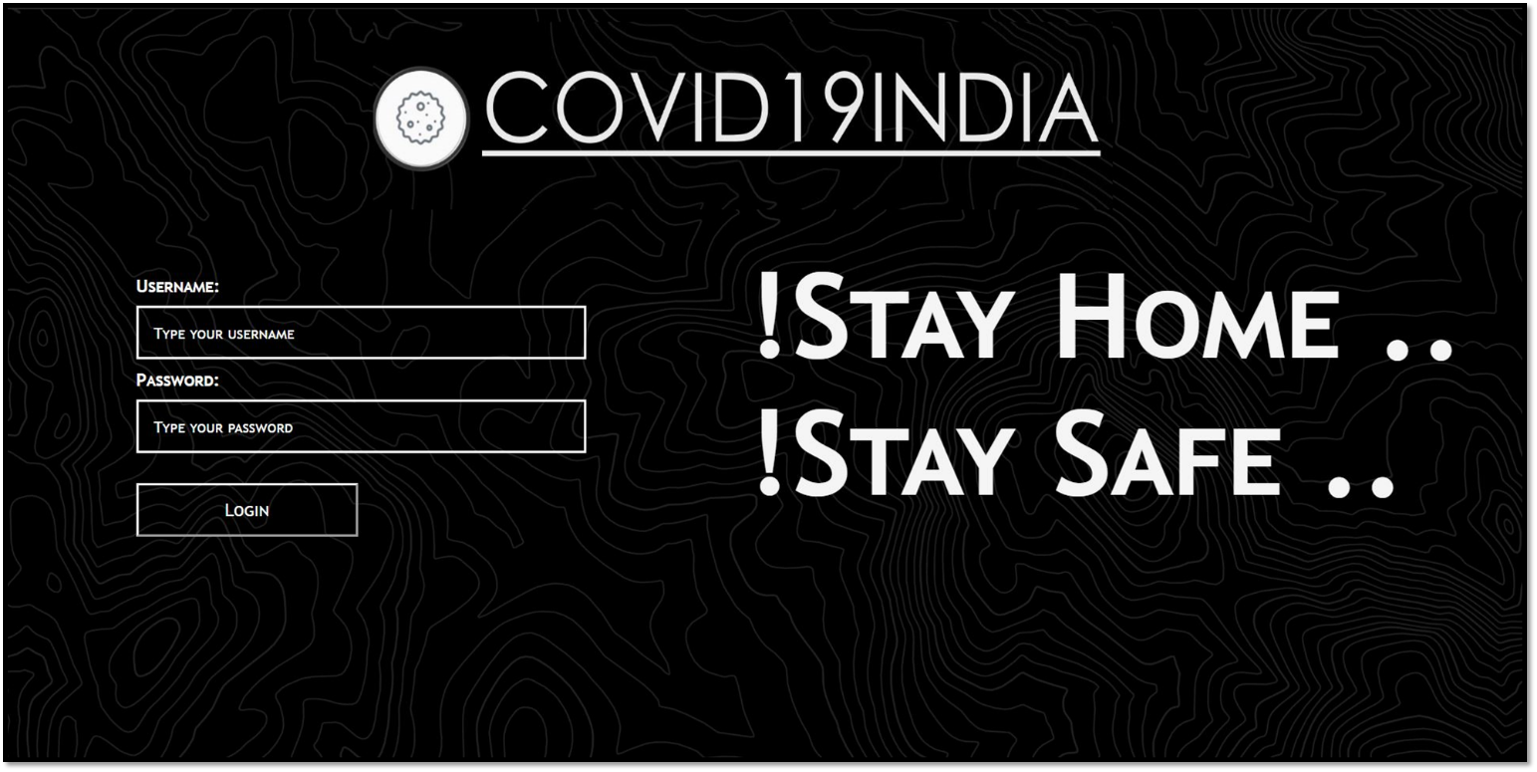

**CONCLUSIONS**

**COVID MANAGEMENT** provides sanitization facilities and door-step medical waste pickup facilities. Our website also gives covid updates, tips on prevention and self care to follow during this pandemic. It makes your work faster and efficient. Also by using these facilities which are of no cost you make sure that you and your neighbor hood is safe.

Our website is a small initiative to contribute towards a safer environment and you can help the nation to be COVID free by taking small steps towards managing your Medical waste and becoming a COVID HERO :’)) .

**REFERENCES**

Textbook:

[1] Leaning Web Design: A Beginner’s Guide

[2] SQL: The Ultimate Beginners Guide

Website:

[1] <https://www.w3schools.com/js/>

[2] <https://www.w3schools.com/php/default.asp>

[3] <https://www.w3schools.com/jquery/default.asp>

[4] <https://www.tutorialspoint.com/html5/html5_web_sql.htm>

[5] <https://www.tutorialspoint.com/sql/sql-insert-query.htm>

[6] <https://www.w3schools.com/js/js_ajax_intro.asp>

***THANK YOU***